Exercise 1: Setting Up JUnit
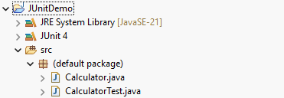
As shown in the above picture a new java project named “JUnitDemo” is created and the JUnit4 libraries are added to this java project.
Calculator.java:
public class Calculator {

public int add(int a, int b) {
return a + b;
}
}

CalculatorTest.java:
import static org.junit.Assert.assertEquals;
import org.junit.Test;

public class CalculatorTest {

@Test
public void testAdd() {
Calculator calc = new Calculator();
assertEquals(5, calc.add(2, 3));
}
}

Output:
